**Containerize The App**

**Date** 14 November 2022

**Team ID** PNT2022TMID47995

**Project Name** Smart Fashion Recommender Application

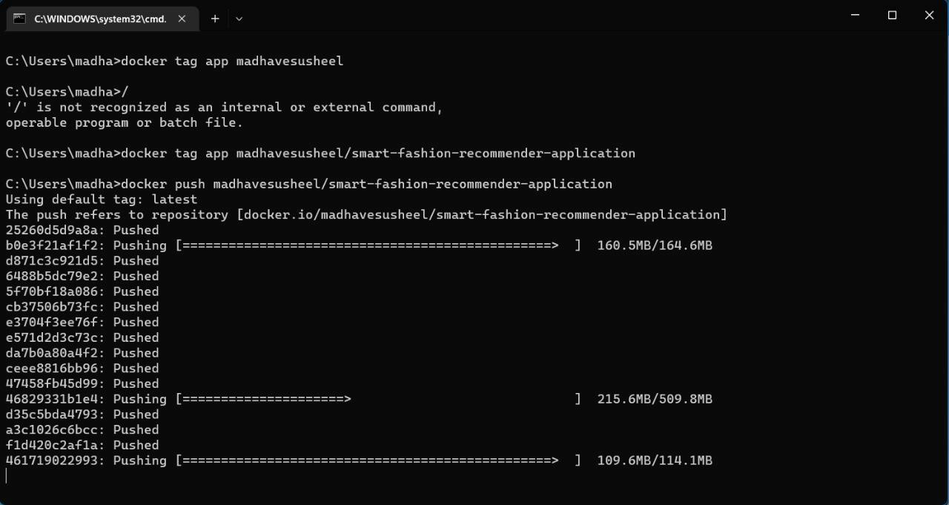

**DOCKER PUSH:**

**CONTAINERIZING THE APPLICATION:**

